Caroline Taylor
C.Taylor11@newcastle.ac.uk

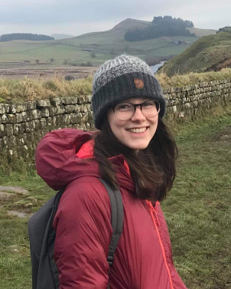
My research focusses primarily on the dynamic risk of Glacial Lake Outburst Floods (GLOF), and the interplay between hazard, exposure, and vulnerability. Until now, much of the research into GLOFs has centred on changing hazard- how glacial lakes are forming and expanding in response to climate driven deglaciation. How this translates to risk to populations living downstream of these glacial lakes remains relatively unexplored. Thus, I am assessing how GLOF risk has and might be expected to change across multiple spatial and temporal scales including at; global, national and catchment spatial scales and at 5-yearly, annual, monthly, and daily time scales.
- How is GLOF risk distributed globally
- How has GLOF risk changed and what is driving it
- How might GLOF risk be expected to change in the future
- How do shorter-term variations in risk drivers’ effect GLOF risk
Numerous techniques will be deployed to quantify GLOF risk over these spatial and temporal scales, from detailed mapping of remotely sensed imagery using GIS software to designing and deploying a new measure of vulnerability. Results of larger-scale analyses (e.g. global, national) will be used to target locations at high risk of GLOF impacts for finer-scale analysis (e.g. catchment). By identifying the drivers behind past GLOF risk change and projecting how these factors might change into the future, my research hopes to identify populations most at risk of GLOF impact and provide targeted mitigation that can be tied in with larger scale development (e.g. UN’s sustainable development goals) as well as those driven by local authorities.
Supervisors
Dr Rachel Carr, Newcastle University, UK
Dr Stuart Dunning, Newcastle University, UK
Dr Matt Westoby, Northumbria University, UK
Dr Tom Robinson, University of Canterbury, NZ
Publications
Taylor, C.J., Robinson, T.R., Dunning, S.A., Carr, J.R. and Westoby, M.J. (in review) Glacial lake outburst floods threaten millions globally: a new metric for quantifying risk.
Taylor, C. J., Carr, J. R., & Rounce, D. R. (2021). Spatiotemporal supraglacial pond and ice cliff changes in the Bhutan–Tibet border region from 2016 to 2018. Journal of Glaciology, 1-13.
Conference Presentations
“Quantifying GLOF risk at a global scale”, EGU, 2021 (online)
“Spatiotemporal supraglacial pond and ice cliff changes in the Bhutan-Tibet border region 2016-2018”, IGS, 2019
“Investigating supraglacial ponds in the Everest region 2015-2018: Changes, Controls and future Risks”, EGU, 2019.

